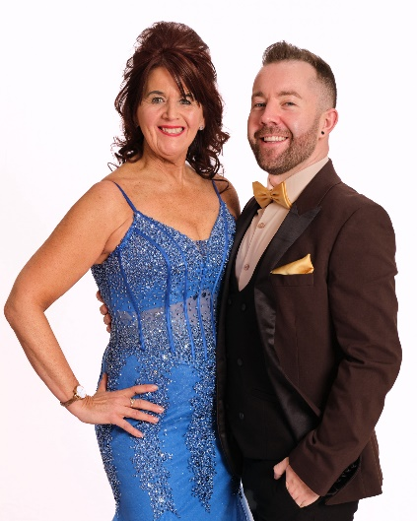
LISTEN TO MY HEART
Choreographed by Maggie Gallagher (UK) & Gary O’Reilly (IRE) June 2024
64 Count 2 Wall Intermediate Level Linedance
Music: Listen by Eloise Viola (2:45)
Intro: Start on the word “Hold” approx 3 secs

S1: ¼ SIDE, TOUCH, ¼, ¼ HITCH, SIDE, POINT/LOOK, ¼, ½
1-2 ¼ right stepping right to right side, Touch left next to right [3:00]
3-4 ¼ left stepping forward on left, ¼ left hitching right knee up [9:00]
5-6 Step right to right side, Point left to left side and look right
7-8 ¼ left stepping forward on left, ½ left stepping back on right [12:00]

S2: BACK, CROSS BALL WALK, WALK, CROSS, SWEEP, CROSS, SWEEP
1-2& Step back on left, Cross right over left, Step slightly back on left
3-4 Walk forward on right, Walk forward on left
5-6 Step forward on right slightly crossing over left, Sweep left from back to front
7-8 Step forward on left slightly crossing over right, Sweep right from back to front

S3: CROSS, BACK, BALL CROSS, SIDE, BEHIND SIDE CROSS, HOLD, ⅛, TOGETHER
1-2& Cross right over left, Step back on left, Step right next to left
3-4 Cross left over right, Step right to right side
5&6 Cross left behind right, Step right to right side, Cross left over right
7&8 HOLD, ⅛ left stepping right to right side, Step left next to right [10:30]

S4: CROSS, ⅛ SIDE, SAILOR ½ R, WALK, WALK, ANCHOR STEP
1-2 Cross right over left, ⅛ right stepping left to left side [12:00]
3&4 ½ right crossing right behind left, Step left to left side, Step forward on right [6:00]
5-6 Walk forward on left, Walk forward on right
7&8 Lock left behind right, Step weight onto right, Step slightly back on left
Restart here on Wall 3 facing [6:00]

S5: PUSH HIPS BACK-FORWARD-BACK, WALK, ½, BACK/POP, STEP, ¼ SIDE
1-2-3 Step back on right pushing hips back, Rock forward on left pushing hips forward, Rock back on right pushing
hips back
4-5 Walk forward on left, ½ left stepping back on right [12:00]
6-7 Step back on left popping both knees, Step down on right
8 ¼ right stepping left to left side [3:00]

S6: BEHIND, SWEEP, BEHIND SIDE CROSS, SIDE ROCK, RECOVER, BEHIND SIDE CROSS
1-2 Cross right behind left, Sweep left from front to back
3&4 Cross left behind right, Step right to right side, Cross left over right
5-6 Rock right to right side, Recover on left
7&8 Cross right behind left, Step left to left side, Cross right over left

S7: SIDE, HOLD & SIDE, POINT/LOOK, ¼, ½, ½, WALK
1-2& Step left to left side, HOLD, Step right next to left
3-4 Step left to left side, Point right to right side and look left
5-6 ¼ right stepping forward on right, ½ right stepping back on left [12:00]
7-8 ½ right stepping forward on right, Walk forward on left [6:00]

S8: BACK/DRAG, BACK/DRAG, REVERSE ROCKING CHAIR
1-2 Walk back on right dragging left to meet right
3-4 Walk back on left dragging right to meet left
5-6 Rock back on right, Recover on left
7-8 Rock forward on right, Recover on left [6:00]

RESTART: Dance 32 counts of Wall 3, then restart the dance from the beginning facing [6:00]

ENDING: After 32 counts of Wall 6, step right to right side to finish facing [12:00]

Thank you to Jane Kenrick for suggesting this track

Contact: Gary O’Reilly - oreillygaryone@gmail.com - +353857819808
https://www.facebook.com/gary.reilly.104 - www.thelifeoreillydance.com
Maggie Gallagher - +44 7950291350
www.facebook.com/maggiegchoreographer - www.maggieg.co.uk

