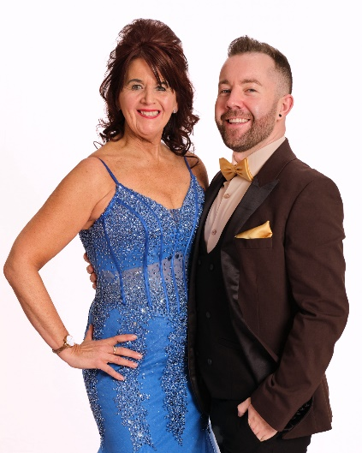
DO IT ALL AGAIN
Choreographed by Gary O’Reilly (IRE) & Maggie Gallagher (UK) May 2024
32 Count 4 Wall Improver Level Linedance
Music: Do It All Again by Guilty Pleasure, Enisa & Faydee (2:51)
Intro: 32 counts (16 secs approx)

S1:WALK, WALK, SIDE ROCK, WALK, ROCK, RECOVER, COASTER CROSS
1-2 Walk forward on right, Walk forward on left
&3-4 Rock on ball of right to right side, Recover on left, Walk forward on right
5-6 Rock forward on left, Recover on right
7&8 Step back on left, Step right next to left, Cross left over right

S2: SIDE, TOGETHER, CHASSE R, CROSS ROCK, RECOVER, CHASSE ¼ L
1-2 Step right to right side, Step left next to right
3&4 Step right to right side, Step left next to right, Step right to right side
5-6 Cross rock left over right, Recover on right
7&8 Step left to left side, Step right next to left, ¼ left stepping forward on left [9:00]

S3: R CROSS SAMBA, L CROSS SAMBA, CROSS, BACK, SIT BACK/POP, RECOVER
1&2 Cross right over left, Rock left to left side, Recover on right
3&4 Cross left over right, Rock right to right side, Recover on left
5-6 Cross right over left, Step back on left
7-8 Sit back on right popping left knee, Recover forward on left

S4: R ROCKING CHAIR, STEP, ¼ HEEL BOUNCE, ¼ HEEL BOUNCE, STEP/FLICK
1-2 Rock forward on right, Recover on left
3-4 Rock back on right, Recover on left
5-6 Step forward on right, ¼ left bouncing both heels [6:00]
7-8 ¼ left bouncing both heels (weight finishing on right), Step forward on left flicking right back [3:00]

ENDING: At the end of Wall 10, cross right over left and unwind ½ left to finish facing [12:00]

Contact:
Gary O’Reilly - oreillygaryone@gmail.com - +353857819808
https://www.facebook.com/gary.reilly.104 - www.thelifeoreillydance.com
Maggie Gallagher - +44 7950291350
www.facebook.com/maggiegchoreographer - www.maggieg.co.uk

